

|  |
| --- |
|  |
| Project Name  Team Name |
| |  |  |  | | --- | --- | --- | | Midterm/Final | Semester and Year | EPICS Design Document | |

Contents

Section 1: Project Identification 3

Resources 3

Project Objective Statement 3

Description of the Community Partner 3

Stakeholders 3

Outcomes/Deliverables 3

User Need List 4

Expected Overall Project Timeline 4

Section 2: Specification Development 5

Resources: 5

Description of the Use Context 5

Benchmarking 5

Specification List 6

Section 3: Conceptual Design 7

Resources: 7

Concept Generation 7

Prototyping 7

Concept Convergence 7

Proposed Solution 7

Section 4: Detailed Design 8

Resources: 8

Summary of Detailed Design Process 8

Bill of Material (B.O.M) 8

Prints/Schematics/Code 8

Manufacturing and Assembly Processes 8

Risk Analysis 9

Verification 9

Validation 10

Section 5: Project Delivery 11

Resources: 11

User/Service Manual 11

Delivery Checklist 11

Customer Satisfaction Questionnaire 11

Section 6: Current Semester Record 12

Appendix A: Past Semester Records 13

# Section 1: Project Identification

## Project Objective Statement

* To enhance road safety and reduce accidents caused by drowsy driving, by developing and promoting the use of innovative technologies and solutions.
* The project is motivated by the need to address the serious issue of drowsy driving. With hectic schedules and long hours, people often find themselves fatigued behind the wheel, leading to accidents and potential loss of lives. The motivation is to enhance road safety and prevent accidents caused by drivers falling asleep.
* The project aligns perfectly with the mission of promoting road safety. By developing a Driver Anti-sleep Device, the team aims to provide a practical solution to a common problem. The technology used in the device reflects a commitment to leveraging innovation for the greater good, ensuring that individuals, especially those on long journeys or driving late at night, can reach their destinations safely.

## Description of the Community Partner

* The project partners could be Emergency Services, Community Advocacy Groups, Local Businesses, Driving Schools, Automobile Manufacturers, Health Organizations, Insurance Companies, Law Enforcement Agencies, Transportation Authorities.
* This mission would align with the goal of creating a safer driving environment, especially for individuals on long journeys or driving during late hours. The focus is likely on leveraging technology to address a critical issue and contribute to overall community well-being.

## Stakeholders

* The impact of a project addressing drowsy driving with a Anti-sleep Alarm extends beyond the immediate customer. Other stakeholders who can be affected by the project include Passengers, Pedestrians and bystanders, Drivers on the Road, Emergency Services, Healthcare System, Insurance Companies, Employers, Government and Regulatory Bodies.
* Maintenance: Regular Check-ups, Battery Replacement, Software Updates (if applicable), User Education, Storage: Dry and Cool Environment, Secure Storage, Labeling and Organization, Protection from Dust, Documentation, Backup Devices, Compliance with Regulations.
* Regular maintenance and careful storage practices contribute to the longevity and effectiveness of the Anti-sleep Alarm, ensuring that it remains a reliable tool for preventing accidents due to drowsy driving.

## Project Scope

* The project results for the Anti-sleep Alarm, the primary result would be an improvement in road safety by reducing accidents caused by drowsy driving. This contributes to a safer driving environment for individuals and the community at large. The project aims to prevent accidents that could lead to injuries or fatalities. The tangible result would be a potential reduction in the loss of lives due to drowsy driving incidents. A decrease in accidents would result in fewer injuries sustained by drivers, passengers, and pedestrians, contributing to a healthier and safer community.
* The project may lead to increased awareness about the dangers of drowsy driving and the availability of technology to mitigate these risks. This could have a positive impact on driving behaviors. The successful implementation of the Driver Anti-sleep Device could lead to widespread adoption of similar technologies, either as standard features in vehicles or as aftermarket safety accessories. The project may foster collaboration and support from various stakeholders, including government agencies, law enforcement, insurance companies, and healthcare providers, all working towards a common goal of road safety.
* Depending on the design, the project may generate valuable data insights related to drowsy driving patterns, helping researchers and policymakers better understand and address this safety issue. The project results could potentially influence or contribute to the development of regulations or policies related to drowsy driving prevention, further enhancing overall road safety. Positive feedback from users and customers who have experienced the benefits of the Driver Anti-sleep Device would be a valuable result, indicating the success of the project in meeting its objectives.
* When the project is completed, your team would ideally leave behind a fully functional and well-documented Driver Anti-sleep Device. This includes Completed Devices, Comprehensive documentation covering device specifications, installation guidelines, maintenance procedures, and troubleshooting steps, Training Material, if the device incorporates software, the source code and relevant documentation should be provided, facilitating future updates and modifications, Test Reports, Support and Contact information for ongoing support or inquiries, ensuring that users can reach out for assistance if needed.
* The functionality in-scope are Drowsiness Detection, Alert System, Reset Mechanism, Timer Mechanism, User-Friendly Interface, ensuring the device is reliable under various driving conditions and scenarios. Power Management.The functionality out-of-scope are Vehicle Control Systems, Medical Diagnostics, Interference with Driving.
* Assumptions by our team are User Responsiveness, Compatibility, the team may assume that the device's detection mechanisms are effective in identifying signs of drowsiness accurately. User Understanding assumptions may be made about users' ability to understand and follow the provided documentation and training materials.

## User Need List

* The impact of a project addressing drowsy driving with a Anti-sleep Alarm extends beyond the immediate customer. Other stakeholders who can be affected by the project include Passengers, Pedestrians and bystanders, Drivers on the Road, Emergency Services, Healthcare System, Insurance Companies, Employers, Government and Regulatory Bodies.
* Several stakeholders would have a vital interest in the success and implementation of the Driver Anti-sleep Device project. These include drivers, families and loved ones, transportation authorities, insurance companies, healthcare providers, etc.

|  |  |  |
| --- | --- | --- |
| Need # | Stakeholder | User Need |
| 1 | Drivers | *The device directly impacts their safety and well-being.* |
| 2 | Transportation Authorities: | *Authorities responsible for overseeing road safety and transportation have a vital interest.* |
| 3 | Emergency Services | *Have a vital interest in projects that reduce the number of accidents and emergencies they need to respond to.* |
|  |  |  |

## Expected Overall Project Timeline

*Project Start Date:* 8/8/2023 *Original Target Delivery Date:* 5/11/2023

Timelines:

Project Initiation (1-2 weeks)

Design and Planning (2 weeks)

Prototyping (3-4 weeks)

Development (1 week)

Manufacturing and Production (3-4 weeks)

Testing and Quality Assurance (2-3 weeks)

Milestones:

* Project Initiation: Project goals, objectives, and scope defined, project team formed, initial market research and feasibility studies completed, project plan and timeline developed.
* Design and Planning: Detailed design of anti-sleep device completed, materials and components selected, manufacturing and testing processes planned; preliminary stakeholder discussions conducted.
* Prototyping: Initial prototypes of anti-sleep device built, initial testing for functionality and user experience conducted, feedback from internal testing gathered, adjustments made to the design based on prototype feedback.
* Development: Final version of anti-sleep device developed, electronic components and software integrated, thorough testing, including simulated and real-world scenarios, conducted.
* Regulatory Compliance: Anti-sleep device complies with safety and regulatory standards, necessary certifications or approvals obtained.
* Manufacturing and Production: Mass production of anti-sleep devices begins, partnerships with manufacturers and suppliers established, quality control measures implemented during production.
* Testing and Quality Assurance: Rigorous testing of manufactured devices conducted, issues or defects identified during testing addressed, consistency and reliability confirmed across all produced units.

# Section 2: Specification Development

## Description of the Use Context

* Usage: The project will be used as a safety device in vehicles to alert drivers when signs of drowsiness are detected. Potential Misuse: Misuse could occur if the device is tampered with or if false alerts are intentionally triggered. It's important to implement security features to prevent unauthorized access and interference.
* Interfaces: The project may interface with a vehicle's electrical system for power. It should have compatibility with various vehicle models. Requirements: The device should meet safety and regulatory standards for electronic devices used in vehicles. Space and Storage Limitations: Physical Size: The device should be compact to fit within a vehicle's interior. Storage Space: Adequate storage space is required for manufactured devices and components. Servers: No external servers are necessary for the device's primary function. ADA Standards: Consideration of accessibility standards for user interfaces, ensuring inclusivity.
* Maintenance: Regular maintenance is crucial for ensuring the device's proper functioning. This may involve software updates, battery replacements, and periodic checks. Management: Site/application management involves overseeing the device's performance, addressing user feedback, and providing necessary support.
* Environmental Conditions: Exposure: The device should be designed to withstand exposure to typical in-vehicle conditions, such as temperature variations. Public Exposure: If exposed to the public, protective measures should be in place to prevent damage or tampering.
* Security Considerations: Unauthorized Access: Security features should prevent unauthorized access to the device's settings. Data Security: If the device collects data, measures should be taken to secure and protect that data.
* Technological Limitations: Detection Accuracy: The effectiveness of drowsiness detection may have limitations based on available technology. Integration Challenges: Compatibility issues with certain vehicle models or electronic systems may arise.
* Other Factors: Cost: Affordability may impact the device's accessibility to a wider audience.
* User Education: Adequate training and educational materials are essential for users to understand and use the device effectively.

## Benchmarking

* Survey of Existing Solutions and Competing Technology:
* Existing Solutions: Existing solutions for drowsiness detection in vehicles include In-vehicle cameras monitoring driver behavior. Wearable devices that track physiological indicators of drowsiness. Systems using steering wheel or lane deviation sensors to detect erratic driving patterns.
* Commercially Available Solutions: Commercially available solutions include Smart dash cameras with built-in driver monitoring features. Wearable smartwatches or headsets with drowsiness detection capabilities. Aftermarket devices that analyze vehicle movements for signs of driver fatigue.
* Comparison and Benchmarking:The proposed Driver Anti-sleep Device could be compared to Leading in-vehicle camera-based monitoring systems. Established wearable devices known for accurate drowsiness detection. Similar aftermarket products with a focus on preventing drowsy driving.
* Potential Barriers from Intellectual Property: Potential barriers could arise if there are existing patents or intellectual property rights related to specific drowsiness detection algorithms or technologies. Conducting a thorough patent search is essential to identify and navigate potential intellectual property challenges. Collaboration or licensing agreements may be explored to address any existing intellectual property constraints.
* Considerations for Community Partner: Assessing the effectiveness, affordability, and user-friendliness of existing solutions is crucial. Benchmarking against well-established products ensures that the proposed solution meets or exceeds industry standards. Understanding potential intellectual property barriers helps in developing a strategy to navigate legal considerations and ensure compliance.
* This survey provides insights into the competitive landscape, allowing the project team to leverage existing technologies, address gaps in current solutions, and develop a Driver Anti-sleep Device that stands out in terms of effectiveness, user acceptance, and affordability.

## Specification List

Specifications are the translation of your User Needs into measurable requirements. To create a list of your project specifications, start by copying your list of user needs. For each user need, list the specifications that you must meet to satisfy that requirement. As you write your specifications, keep in mind you must be able to test the product to ensure that the specification has been met.

|  |  |  |  |
| --- | --- | --- | --- |
| Need # | User Need | Spec # | Specification |
| 1 | *Drowsiness Detection* |  |  |
|  |  | 1.1 | *Achieve a minimum accuracy rate of 95% in detecting signs of drowsiness based on real-world testing scenarios.* |
| 2 | *Alert System:* |  |  |
|  |  | 2.1 | *Audible alert should have a volume of at least 85 decibels to ensure it is heard by the driver.* |
|  |  | *2.2* | *Visual alert should be prominently displayed on the device with high visibility.* |
| 3 | *Durability:* |  |  |
|  |  | 3.1 | *The device must withstand vibrations equivalent to those experienced during normal vehicle operation.* |
|  |  | 3.2 | *Materials used in construction should be resistant to temperature variations within the standard in-vehicle range.* |
| 4 | Reset Mechanism: | 4.1 | *The reset mechanism must be easily accessible to the driver without causing distraction.* |

# Section 3: Conceptual Design

## Concept Generation

* Method Used for Ideation: One effective method for ideation we used is brainstorming sessions. In a team setting, members shared their thoughts, and the collective input that led to creative solutions. Additionally, incorporating techniques like mind mapping, concept mapping, or even design thinking workshops enhanced the ideation process.
* Sufficiency of Concepts Generated: The team generated a substantial number of concepts through the ideation process, ensuring a diverse range of ideas that catered to various aspects of the functionality and design. Multiple brainstorming sessions and collaborative discussions were held to encourage creativity and innovation within the team.

Viable Concepts:

* Camera-Based Detection System:
* Wearable Device Integration:
* Steering Wheel-Based System:
* Machine Learning Algorithm:
* Haptic Feedback Integration:
* Combination of Sensors:

## Prototyping

* Purpose of the Prototype: The purpose of this prototype is to demonstrate a drowsiness detection and prevention system for drivers using an Arduino Nano and an eye blink sensor. The system aims to enhance road safety by alerting drivers when they show signs of drowsiness, preventing potential accidents.
* Intended Audience: The concept is primarily designed for drivers to wear the eye blink sensor during driving. The prototype can be used for internal testing within the project team to validate the effectiveness of the drowsiness detection system.
* Simplifications Made:
* Material: The prototype may use simplified materials for the eye blink sensor frame to demonstrate the concept's functionality.
* Geometry: The physical design of the eye blink sensor frame may be simplified for prototyping purposes, focusing on the functionality rather than aesthetics.
* Fabrication of the Prototype: The prototype is likely fabricated through the following steps:
* Arduino Nano Integration: Connect the Arduino Nano to the eye blink sensor and program it to detect prolonged eye closure indicative of drowsiness. Vibrator and Buzzer Integration: Connect a vibrator and buzzer to the Arduino Nano to provide both tactile and auditory alerts when drowsiness is detected.
* Prototype Testing and Observations:
* Concept Learning:
* The team observed that the integration of the eye blink sensor with Arduino Nano effectively detected prolonged eye closure, indicating potential driver drowsiness.
* The vibrator and buzzer alerts provided immediate and noticeable feedback to the driver, serving as effective preventive measures.
* Prototype Testing and Observations:
* The team observed that the integration of the eye blink sensor with Arduino Nano effectively detected prolonged eye closure, indicating potential driver drowsiness. The vibrator and buzzer alerts provided immediate and noticeable feedback to the driver, serving as effective preventive measures.
* User Excitement and Frustration: Excitement: Users expressed excitement about the simplicity and ease of wearing the eye blink sensor frame. The real-time alerts through vibration and sound were well-received as they provided a quick and direct response to potential drowsiness. Frustration: Some users found the prototype frame slightly uncomfortable during extended use, leading to minor discomfort. There were occasional false alarms, causing frustration among users when the system detected drowsiness inaccurately.
* Decisions and Design Changes: Comfort Enhancement: To address user discomfort, the team decided to explore more ergonomic and comfortable materials for the eye blink sensor frame. This could involve using softer materials or adjusting the design for a better fit. User Interface Improvements: Based on user feedback, the team decided to enhance the user interface of the system, making it more intuitive and user-friendly. This could involve simplifying the setup process and providing clear instructions for users. Power Consumption Optimization: Observations revealed that optimizing power consumption for prolonged device usage was essential. The team explored ways to extend battery life and reduce the need for frequent recharging.

## Concept Convergence

|  |  |  |  |  |  |  |  |
| --- | --- | --- | --- | --- | --- | --- | --- |
| ***Material Selection*** |  | ***Plastic*** | | ***Stainless Steel*** | | ***Stainless Steel + Rubber Grip*** | |
| ***Criteria*** | ***Weight*** | ***Score*** | ***Total*** | ***Score*** | ***Total*** | ***Score*** | ***Total*** |
| *Feasibility* | *4* | *2* | *8* | *5* | *20* | *4* | *16* |
| *Cost* | *5* | *2* | *10* | *5* | *25* | *4* | *20* |
| *User-Friendly* | *2* | *3* | *6* | *2* | *4* | *5* | *10* |
| *Efficiency* | *3* | *5* | *15* | *3* | *9* | *2* | *6* |
| *Durability* | *2* | *2* | *4* | *4* | *8* | *3* | *6* |
|  | ***Total*** |  | *43* |  | *66* |  | *58* |

## Proposed Solution

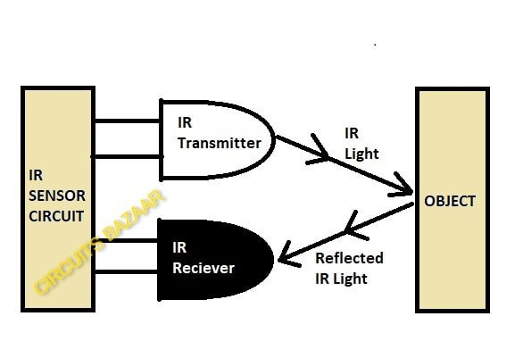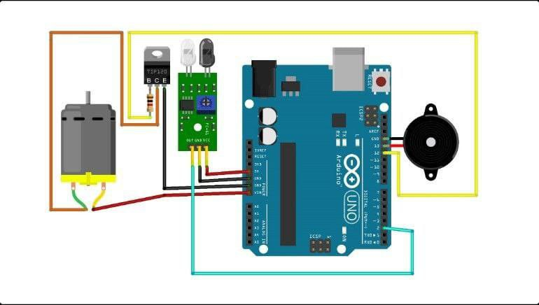

# Section 4: Detailed Design

## Bill of Material (B.O.M)

|  |  |  |  |  |  |  |
| --- | --- | --- | --- | --- | --- | --- |
| Sub-Assembly | Item | Catalog/  Part No. | Manufactured/  Purchased | Vendor/  Method | Quantity | Cost/  Unit |
| *Arduino* | *Arduino Board* | *n/a* | *Purchased* |  | *1* | *Rs.250* |
| *Energy Assem.* | *LEDs* | *n/a* | *Purchased* |  | *2* | *Rs.70* |
| *Energy Assem.* | *9 volts battery* | *n/a* | *Purchased* |  | *1* | *Rs.20* |
| *Arduino* | *Buzzer* | *n/a* | *Purchased* |  | *1* | *Rs.30* |
| *Energy Assem.* | *resistor* | *n/a* | *Purchased* |  | *1* | *Rs.4* |
| *Wire Assem.* | *wires* | *n/a* | *Purchased* |  | *20* | *Rs.150* |
| *Sensor* | *Eye Sensor* | *n/a* | *Purchased* |  | *1* | *Rs.300* |
| *Plastic* | *Tire toy* | *n/a* | *Purchased* |  | *1* | *Rs.100* |
|  |  |  |  |  |  |  |

## Prints/Schematics/Code

const int blinkPin = 2;

const int motorPin = 13;

const int buzzerPin = 12;

long time;

void setup() {

pinMode(motorPin, OUTPUT);

pinMode(buzzerPin, OUTPUT);

pinMode(blinkPin, INPUT);

digitalWrite(motorPin, HIGH);

}

void loop() {

if(!digitalRead(blinkPin)){

time=millis();

while(!digitalRead(blinkPin)){

if(TimeDelay()>=2)digitalWrite(buzzerPin, HIGH);

if(TimeDelay()>=5)digitalWrite(motorPin, LOW);

delay(5000);

}

}

else digitalWrite(buzzerPin, LOW),digitalWrite(motorPin, HIGH);

}

int TimeDelay(){

long t=millis()-time;

t=t/1000;

return t;

}

## Manufacturing and Assembly Processes

We have first designed the code according to our plan mapping and according to that we have bought the components and connected all of them. Components:

Arduino Nano: The central processing unit for the system, responsible for analyzing data from the eye blink sensor and triggering alerts. Eye Blink Sensor: The sensor frame worn by the driver to monitor eye movements and detect signs of drowsiness. Vibrator: Provides tactile feedback to the driver when drowsiness is detected. Buzzer: Offers auditory alerts to the driver as an additional warning signal.

## Risk Analysis

Identifying potential risks is crucial for any project. Here are some potential risks associated with the proposed drowsiness detection and prevention system:

User Discomfort:

Risk: The wearable eye blink sensor frame may cause discomfort or irritation to the driver, leading to reluctance in using the device.

Mitigation: Iterative design improvements to enhance comfort, using ergonomic materials and adjusting the frame design based on user feedback.

Limited Compatibility:

Risk: The system may not be compatible with all types of vehicles or may face challenges in integrating with certain vehicle models and electronic systems.

Mitigation: Thorough testing across a range of vehicles, collaboration with automotive experts, and designing the system with adaptability in mind.

## Verification

|  |  |  |
| --- | --- | --- |
| Spec # | Specification | Verification |
|  |  |  |
| 1.1 | *Achieve a minimum accuracy rate of 95% in detecting signs of drowsiness based on real-world testing scenarios.* | *Minimum accuracy is acquired* |
|  |  |  |
| 2.1 | *Audible alert should have a volume of at least 85 decibels to ensure it is heard by the driver.* | *Volume is at least 85 decibels* |
| 2.2 | *Visual alert should be prominently displayed on the device with high visibility.* |  |
|  |  |  |
| 3.1 | *The device must withstand vibrations equivalent to those experienced during normal vehicle operation.* | *The device withstands the vibrations.* |
| 3.2 | *Materials used in construction should be resistant to temperature variations within the standard in-vehicle range.* | *Materials are resistant to temperature.* |
|  |  |  |

## Validation

|  |  |  |
| --- | --- | --- |
| Need # | User Need | Validation |
| 1 | *The alarm should be heard.* | *The buzzer makes sound when the eye is shut for 5 secs.* |
| 2 | *Eye Sensor detects.* | *The eye senses the eye.* |
| 3 | *Materials withstand the temperatures.* | *The materials withstand the temperature variations within the vehicle range.* |
|  |  |  |

# Section 5: Project Delivery

## User/Service Manual

A user manual should be provided to the community partner to aid them in use and basic maintenance of the product. An in-house manual or engineer to engineer guide may also be created to aid future teams in servicing and troubleshooting the product. Insert a link to each manual here.

## Delivery Checklist

Eye Sensor

Arduino

Buzzer

## Customer Satisfaction Questionnaire

* Customer Satisfaction Questionnaire: <https://tinyurl.com/EpicsCustomerSatisfaction>

## Record of project delivery

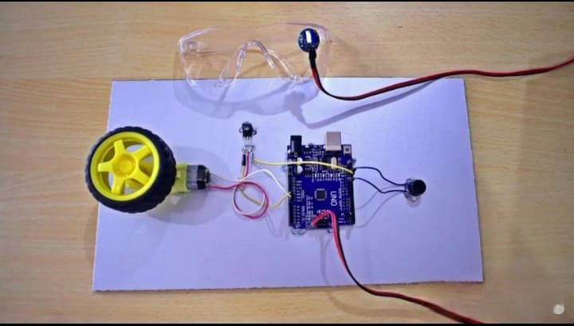

# Section 6: Current Semester Record

## Point of Contact for Future Team Members (E.g design lead)

|  |  |
| --- | --- |
| Name:Sai Dutta |  |
| Email:2210030422@klh.edu.in |  |
| Phone: |  |

## Point of Contact at the commmunity partner organization

|  |  |
| --- | --- |
| Name:Ramani |  |
| Email:2210030255@klh.edu.in |  |
| Phone: |  |

## Current Project Status

Completed

## Current Semester Project Timeline

This section should address such questions as:

* What major milestones will we complete this semester?
* What details should we be working on now?
* The most common tool for project planning in industry is the Gantt Chart

## TRANSITION REPORT

This section should include:

* Storage location and login info for all team materials (code, CAD models, etc)
* Major milestones completed
* Major roadblocks encountered and suggested remedy
* Suggested next-steps for next semester’s team
* Team leadership roles that have been established for next semester

# Appendix A: Past Semester Records